

Durham University DiRAC HPC Facility Adds Immersion Cooling
Executive Briefing
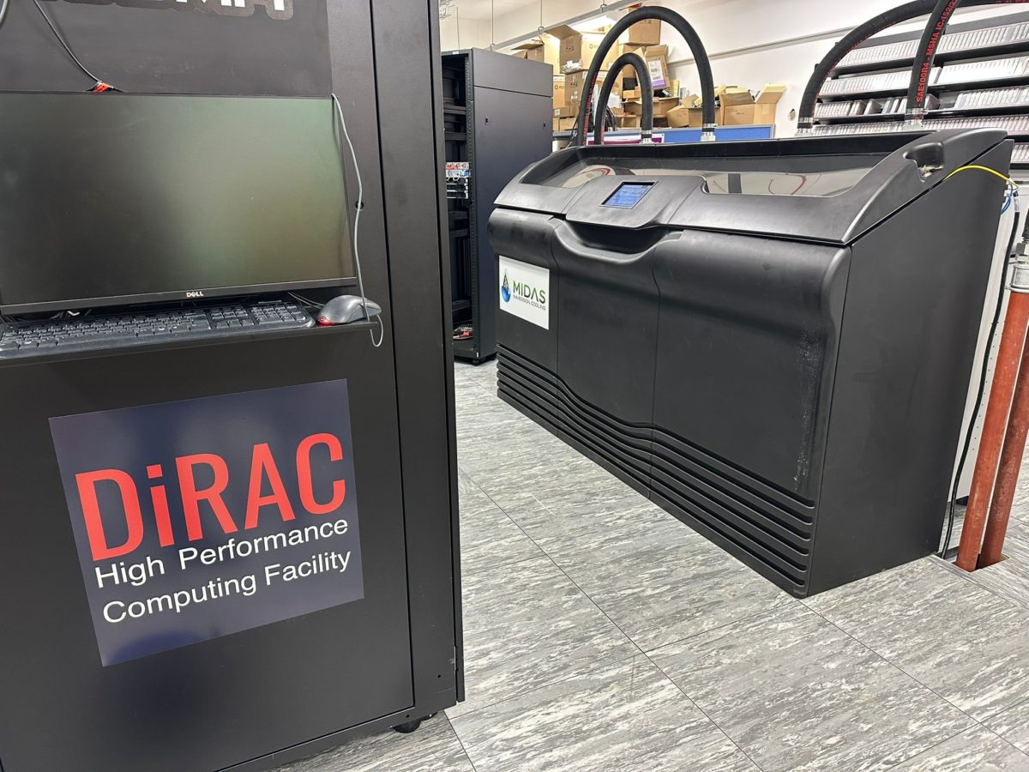

Durham University's DiRAC HPC Facility – Spring 2025
Durham University operates the COSMA HPC system, now in its 8th generation, on behalf of the national DiRAC facility delivering HPC resources for theory communities across the UK. The COSMA facility also includes a HPC Hardware Lab, and a HPC system dedicated for use by local researchers. A primary focus for COSMA is cosmology research, and COSMA systems are Memory Intensive, having a much higher average RAM capability than traditional HPC systems.
Durham University has two mature data centre rooms dedicated for High Performance Computing on campus. These rooms are a good example of a mixed use, modern environment counting several rows of traditional racks supporting the various needs of campus departments, regional and national facilities. The oldest equipment is hosted in air-cooled racks, or racks with passive liquid cooled rear doors. Newer systems use a mix of active rear door heat exchangers and/or direct liquid cooling, particularly for higher end workloads using a Direct to Chip model.
The challenge that Durham is facing is to continue to deploy new higher requirement computing hardware targeted for new workloads while DC space, power and cooling is limited for new/road-mapped hardware.
The Immersion Cooling and Heat Storage (ICHS) project was funded as part of an innovative grant to investigate issues around HPC waste heat, and is comprised of two main components: inter-seasonal waste heat storage in abandoned flooded mine workings, and investigation of Immersion Tank facilities. This research grant allows Durham to explore Immersion Cooling technologies and investigate the efficiencies that can be achieved, also providing support for compute support staff from across the UK to visit the facility as a learning experience.

Durham Decides on Immersion Cooling – Spring 2025
Durham University has considered several options for new hardware deployment critical to maintaining ongoing service delivery to academic researchers. Existing DLC racks are performing well however higher power compute servers and a need to innovate in the cooling space led to consideration of alternative technologies. Durham decided to take bids for a Single-Phase Immersion Cooling solutions to drive the space and scale efficiencies needed, and most importantly to enable the Research Technical Professionals operating the systems to gain experience with installing and operating this technology, which would provide confidence with this solution in future large procurements. A RFQ was tendered by Durham to the open market seeking responses.
SHOULD WE ATTACH THE ORIGINAL RFQ? – Probably not.
Durham’s need to improve data center energy efficiency and evaluate immersion cooling in a real HPC environment, had a longer-term view toward understanding how waste heat could be captured and reused. Their requirement was at least 20U of equipment capacity, a minimum heat dissipation target of 1 kW per U; to connect into the existing primary cooling circuit and support a minimum of five HPC servers, with an additional node incorporating an NVIDIA H100 GPU, with an 18-20°C input and 23-25°C output (or higher). Durham sought a partner model that included on site deployment support, hands on training, and a clear support path for parts replacement and escalation, as well as remote monitoring and alerting to track key operating conditions.

Durham Decides on Immersion Cooling – Summer 2025

50U Midas XCI single-phase immersion cooling tank with redundant architecture and SNMP-based monitoring, was populated with six servers. The initial configuration includes five AMD-based systems (each with 256 cores and 1.5TB RAM) and one Intel-based node with an NVIDIA H100 GPU, supporting workloads ranging from complex simulation (including cosmological simulation) to large-scale AI processing. The tank is integrated into the university’s existing chilled-water loop using 2-inch dry disconnects, and the system was filled with Valvoline dielectric mineral oil during commissioning; with a tank temperature of 50°C (the hottest point in the cycle) the setup can dissipate around 120 kW with an incoming water temperature of 30°C at 140 liters per minute.
Vespertec, Midas, and Durham engineers worked side by side through installation, integration to the chilled-water loop, filling and circulation of the dielectric fluid, and staged server power-up during commissioning. The deployment included operational training for Durham’s engineers covering day-to-day use, monitoring, and basic maintenance activities such as draining, refilling, and CDU checks as part of the handover process.
Vespertec led the integration effort, including solution design, system assembly and validation prior to delivery, and on-site commissioning support. Valvoline supplied the selected dielectric mineral oil used for the initial deployment. Gigabyte systems were used for the immersion server nodes in the initial configuration.
VesperTec room for overview of their contribution to the project.
Valvoline room for overview of their contribution to the project.
Durham room for reasoning behind their choice to choose Midas & team.
The Vespertec/Midas solution was selected as it offered highest value for money, was within budget, and provided confidence that a deliverable and workable solution would be achieved.

Transition from Direct-to-Chip (DLC) cooling to immersion for higher density compute environments.
Durham reasoning for moving away from DLC.
The COSMA HPC facility at Durham, which includes national DiRAC infrastructure and an innovative HPC Hardware Lab, are leading innovators in the HPC space, and have consistently been early adopters of new cooling technologies. Developing practical hands-on experience with installation and operation of immersion cooling was therefore key in maintaining the facility at the cutting-edge of technologies across the HPC space. Additionally, by opening up the immersion tank to RTPs from across the UK to visit and experiment with, this facility is key to delivering training benefits UK-wide.
Midas’ core values provide key benefits for Durham’s needs and requirements. Driving increased density and power efficiency compared to their existing DLC and Air-Cooled systems. Primary value driver was being able to deploy denser workloads while being more efficient on power utilization in the existing facility, with increased waste heat temperatures.

Call to Action
Request an immersion cooling feasibility and scaling plan. We’ll calculate expected energy savings, heat and water reuse opportunities, and HPC density for your facility, and define clear implementation stages from proof of concept to scale-up for AI and GPU workloads, designed to support extended hardware life. MIDAS has operated from Austin, Texas since 2011, with over 4,000 tanks deployed worldwide and nearly 500 MW of heat rejection achieved.
Interested parties seeking more information or direct contact with any of the team above can reach out to John Griffith, Global Sales Manager of Midas Immersion Cooling at johng@midasgt.com. He will provide correct contact sharing to the appropriate team.

Improve energy efficiency, reduce operational costs, and future-proof the facility.

Solution Components

🔹 Midas XCI Immersion System

High-density cooling tanks (XCI 50U) rated up to 150kW.

Hot-swappable CDUs for concurrent maintainability and minimal downtime.

Web-based control interface with SNMP integration.

🔹 Valvoline HTF DE1 Fluid

Engineered for high-flow water distribution with N+1 redundancy.

Immersion cooling enables 10–25% more compute per watt compared to DLC.

Most OPX attributed to IT power, with immersion reducing fan-related overhead.

Remote and on-site support available; training included in startup services.

Midas chosen for technical superiority, financial efficiency, and unmatched uptime.

Hot-swappable modules and fault-tolerant design set Midas apart from competitors.

Call to Action

Interested parties are encouraged to contact project leads for collaboration opportunities.

References/Contacts
List of attached technical metric documents and contacts listed for all those associated to the project.
Contact Information
Dr Alastair Basden – Director of HPC, Durham University
Scott Constable – VesperTec
John Griffith – Midas Immersion Cooling
Scott Sickmiller – Midas Immersion Cooling
Valvoline Team etc

BELOW MATERIAL ADDED AS REFERENCABLE/EXAMPLE DIAGRAMS THAT WILL BE INCORPORATED INTO ABOVE OUTLINE

Midas XCI 50U Tank
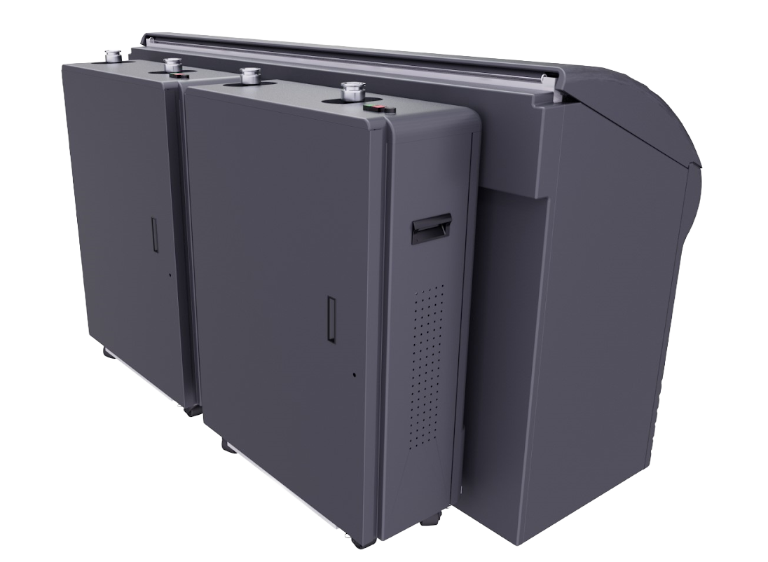

General Description

The Midas System utilizes the basic principles of immersion cooling but builds on top of them to provide its users with the most advanced, highest density, and efficient cooling method. The Midas System is available in different size and capacity configurations.
The MIDAS XCI 50U Tank is engineered to cool up to 150 kW (cooling water loop dependent) with single or redundant cooling distribution units.

Specifications
Table 1: Midas XCI System Specifications
Heat Dissipation Capacity | Up to 150kW
Immersed Server Capacity | 50U + 4x 1U slots
Maximum Server Depth | 36.5" (0.93m)
Dimensions (LxWxH) | 94"x44"x60" (2.39m x 1.12m x 1.52m)
Leveling Requirements | A flat 110" x 110" (2.8m x 2.8m) with <1/8" (3.2mm) slope
System Power Consumption | 0.2-2.5kW
Water Connections | 2" NPT
Water Requirements | 75GPM -39.5°C (For 75kW)
Ambient Heat Loss | .5-2kW
Liquid Volume | 440 gal / 1666L
Tank Dry Weight | 750lb / 340kg
Tank Weight with Dielectric | 3,800lb /1,724kg
Module Dry Weight | 450lb / 204kg
Pressure Rating (Tank & Coolant) | 125 lbs./SqFT
Pressure Rating (Tank & Coolant & 50 servers) | 207 lbs./SqFT
Pump Rating | 3 hp
Power Requirements (Tank) | 120-240V/1ph/50-60hz 1A (from PDU)
Power Requirements (Each Module) | 415-480V/3ph/50-60hz/10A
Network | SNMP, SNTP and DHCP Client Enabled
Web Interface | Yes
Concurrent Maintainability | Yes
Hot Swappable | Yes
Redundancy | N, N+1, 2N, 2N+N

Dimensional
Midas XCI 50U Dimensions
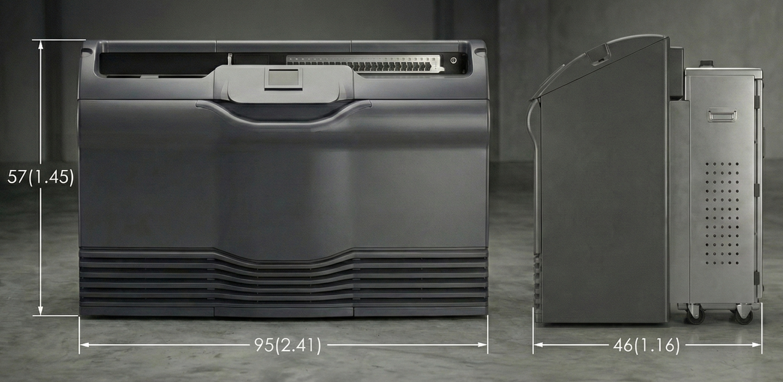
Figure 5: Midas XCI 50U Dimensions
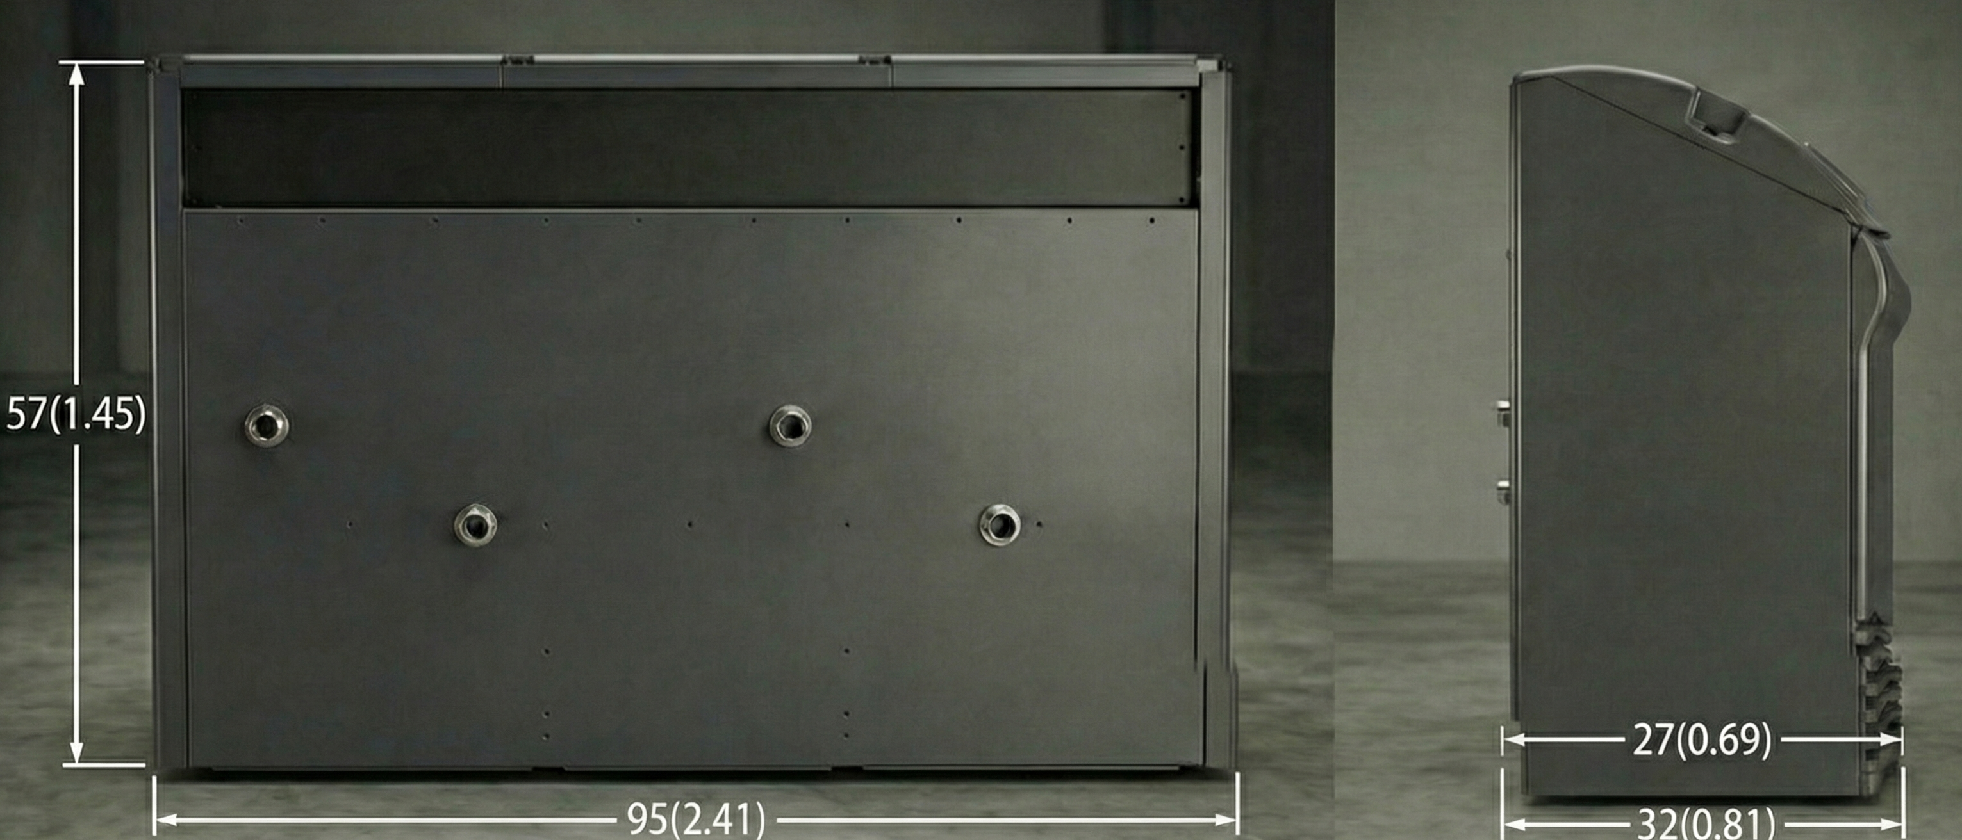
Figure 6: Tank Only Dimensions

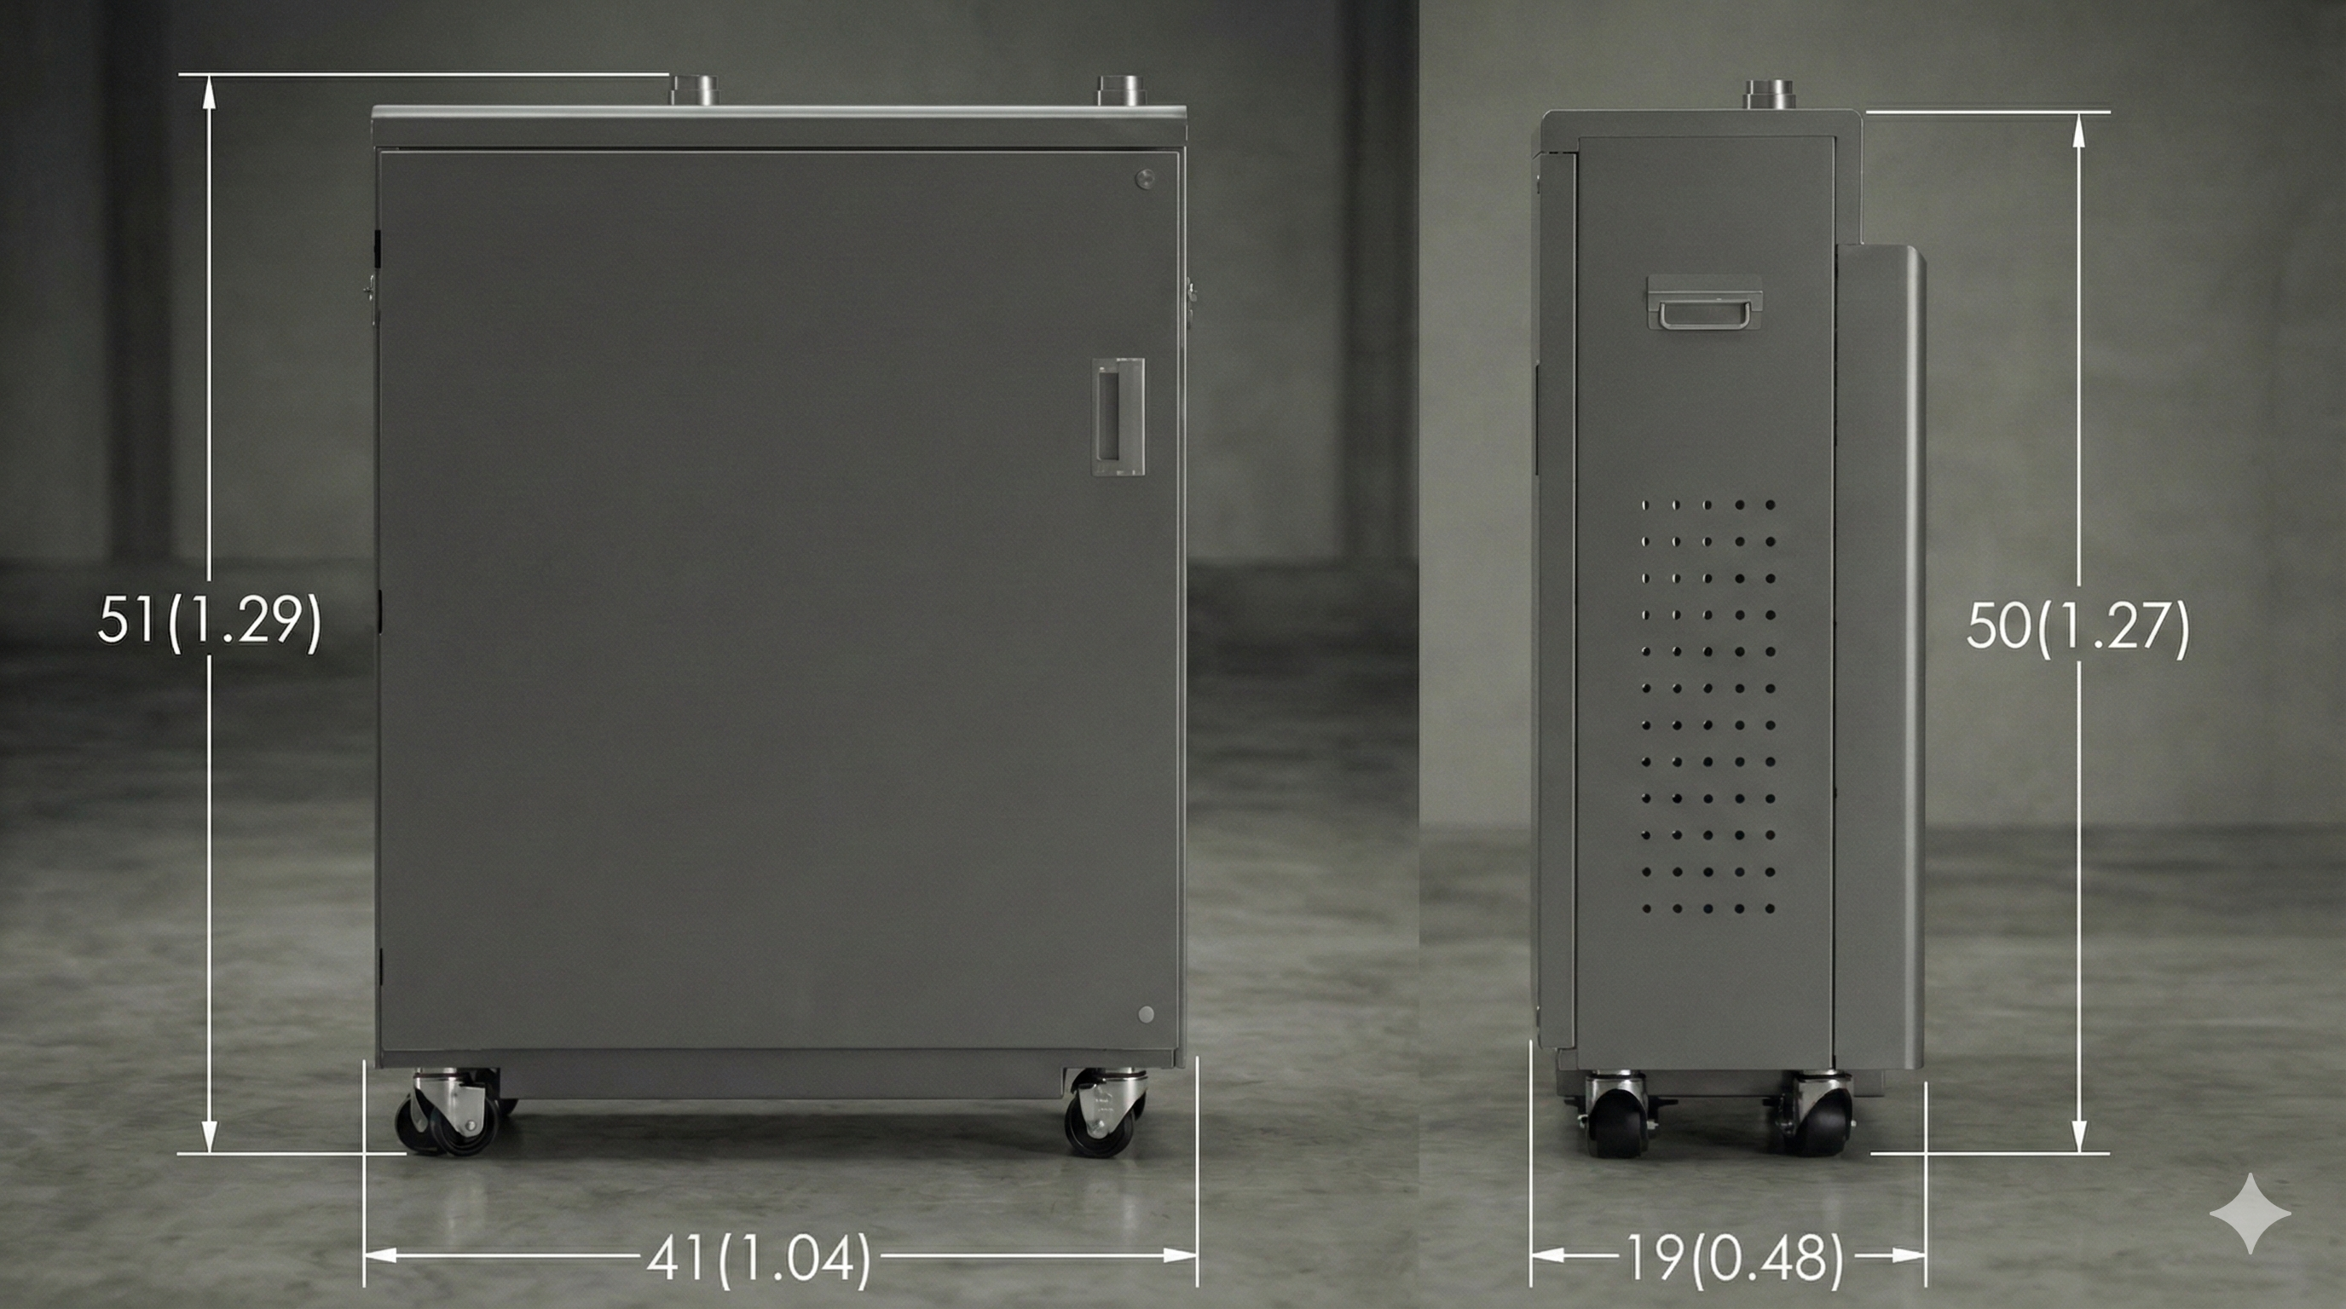

Figure 7: CDU Only Dimensions

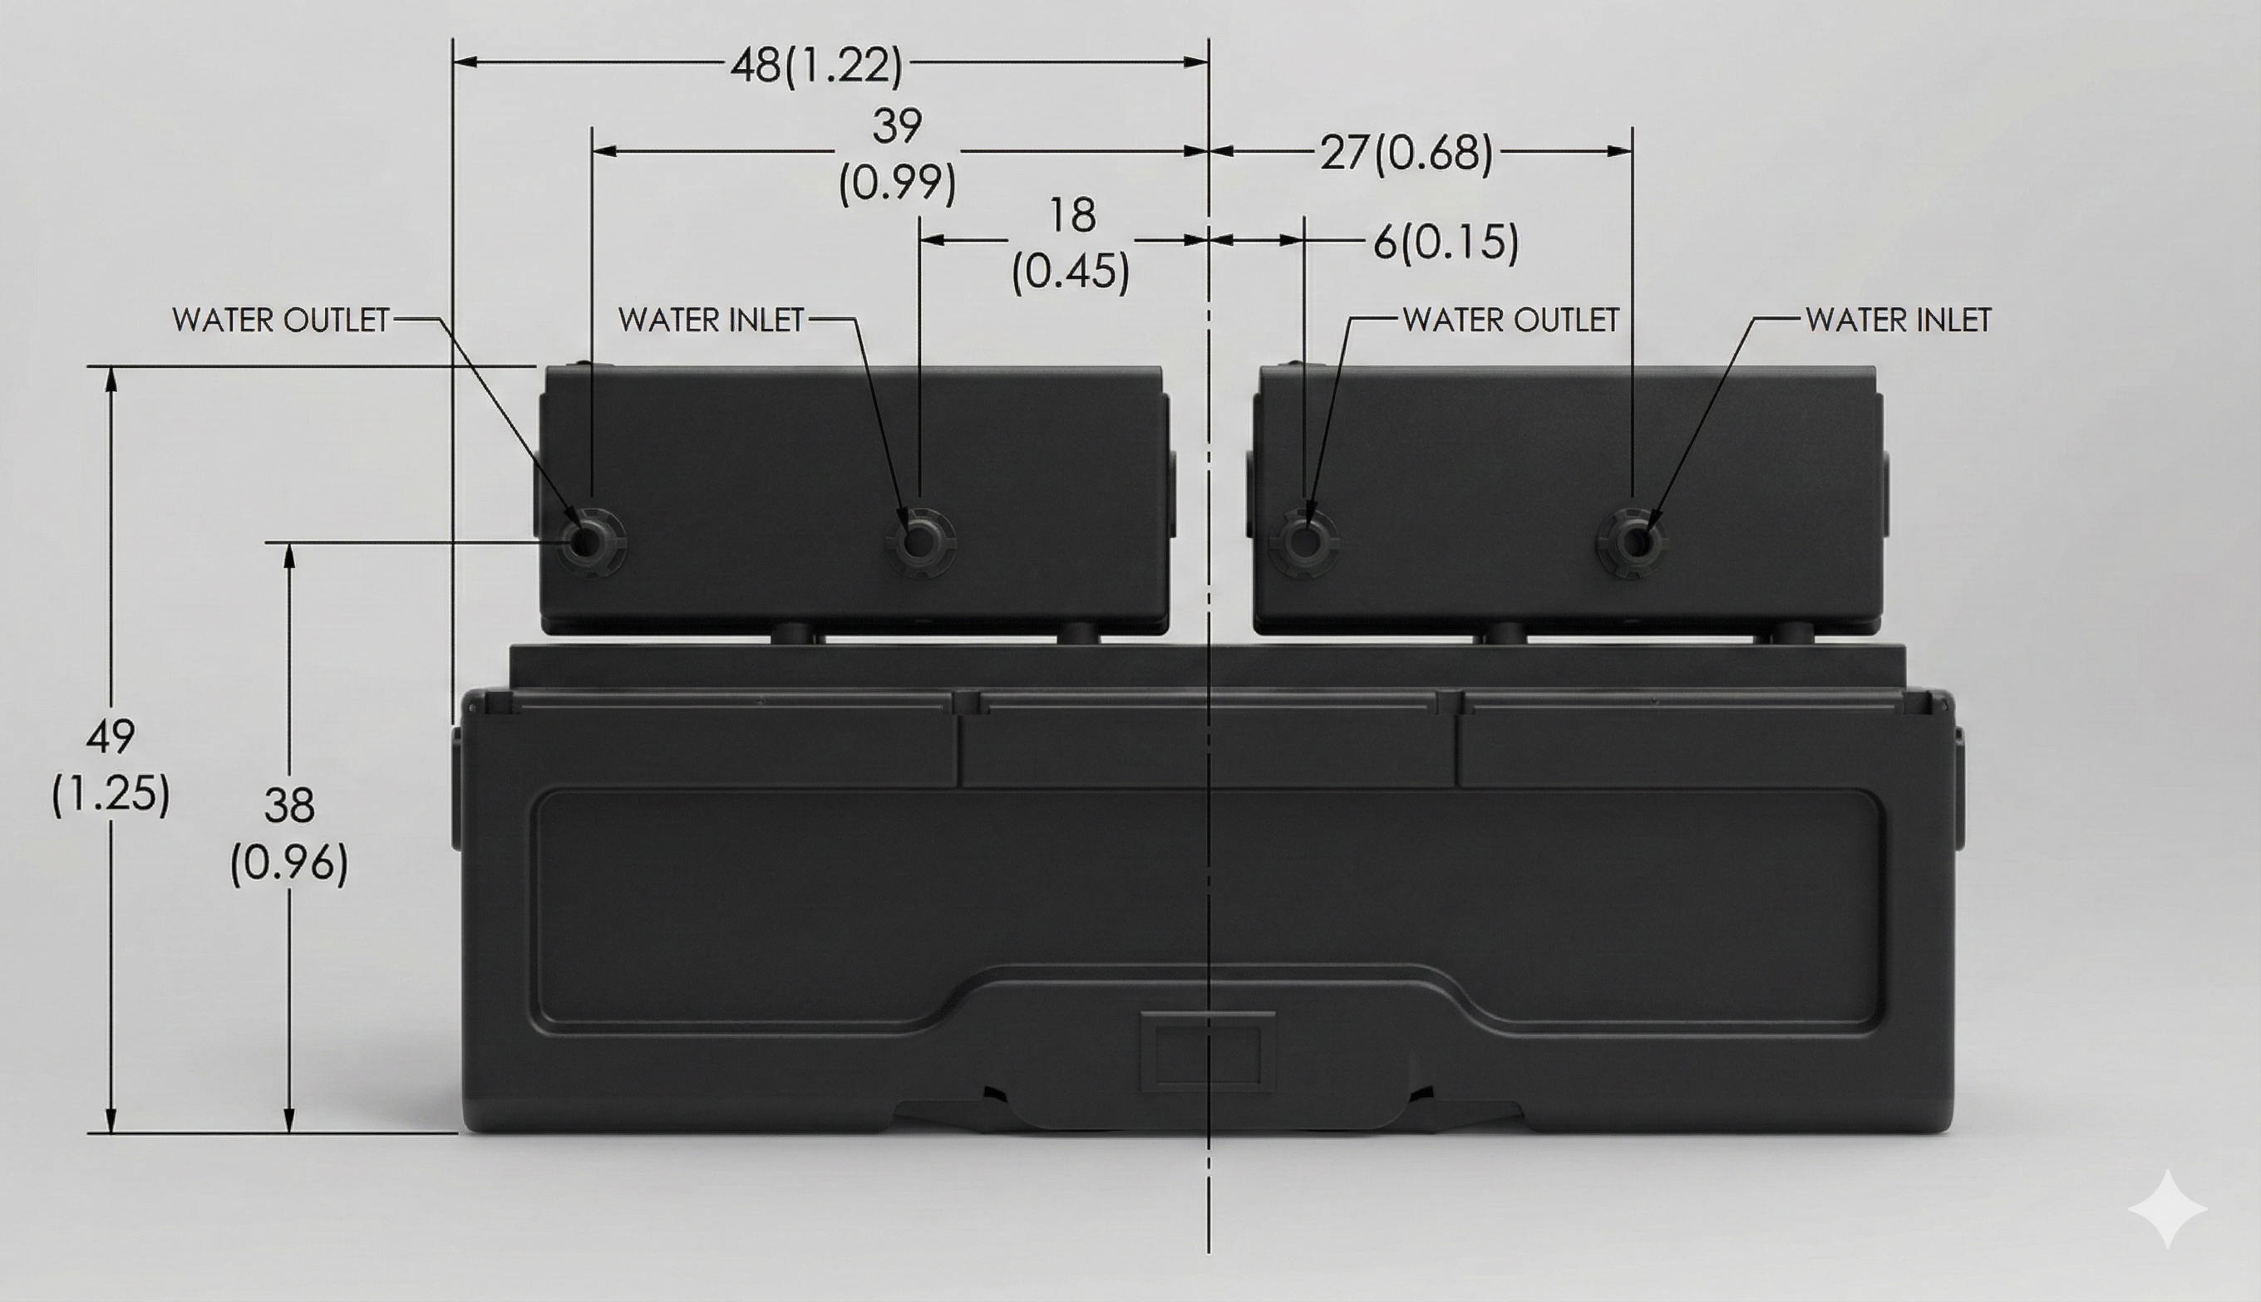
Figure 8: CDU Connection Coordinates
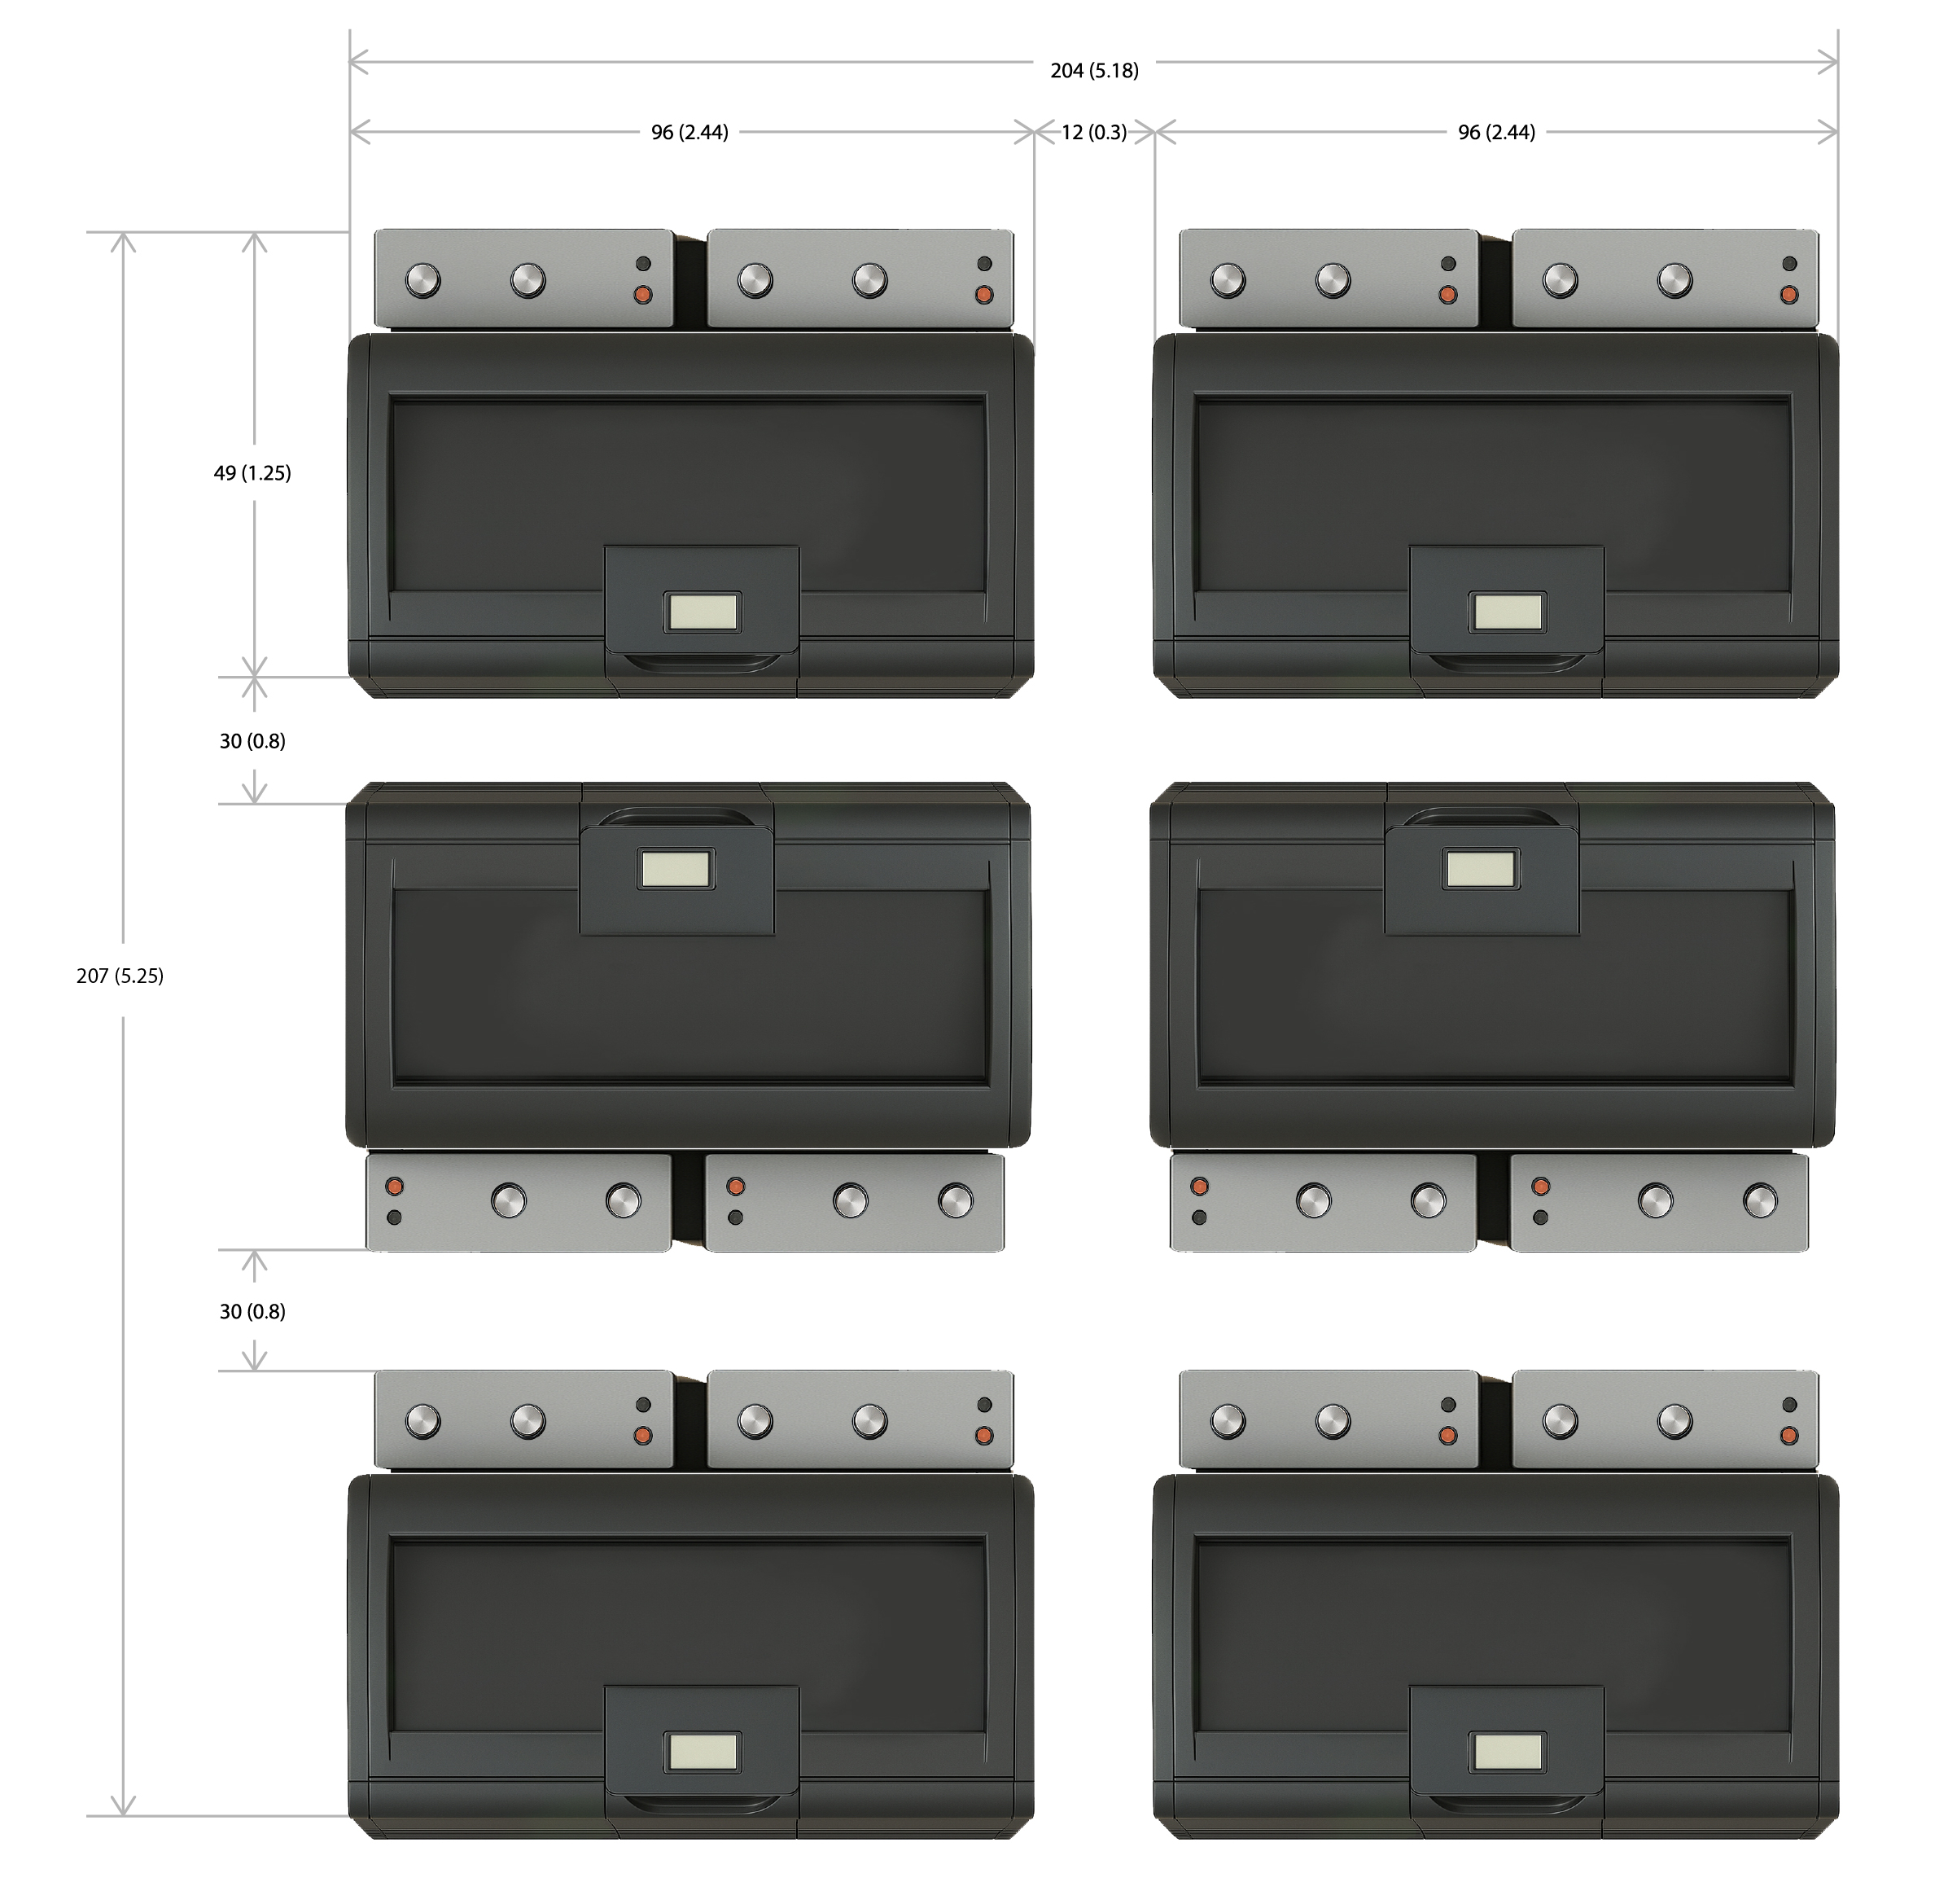
Figure 9: Suggested Layout Spacing

Thermal Capacity
Each Midas XCI 50U Tank is rated for up to 150kW but can be optimized based on customer specifications.

Concurrent Maintainability Example
The Midas XCI systems are engineered to provide the highest level of reliability by making the CDUs hot swappable. A cooling module is equipped with quick dry disconnects that allow connecting to the tank and facility loop within a couple of minutes. With quick network and power connections a cooling module can be removed and replaced in less than 10 minutes.
This process can be done after a quick 20-minute training, and for redundant systems, the module is replaced while the partner CDU is taking care of all the cooling needs of the system ensuring no break in cooling.
Midas recommends having a few spare CDUs. This will allow a system to be concurrently maintainable and fault tolerant. Indeed, if a module fails, it can be replaced; if as soon as the other module is replaced the other one fails,’ it would be possible to have both CDUs replaced within 20 minutes and be left with a system with full 2N redundancy. This process can be performed by a non-specialized employee. This allows us to reduce emergency response costs and requirements. For instance, picture a module failing midnight Saturday, a trained security guard would be able to perform a module switch within minutes. This would bring the system back to full redundancy. Emergency averted; it would be possible to wait until Monday morning for a technician to repair as the failed module will not be connected to any functional system, but instead turn into the new spare.
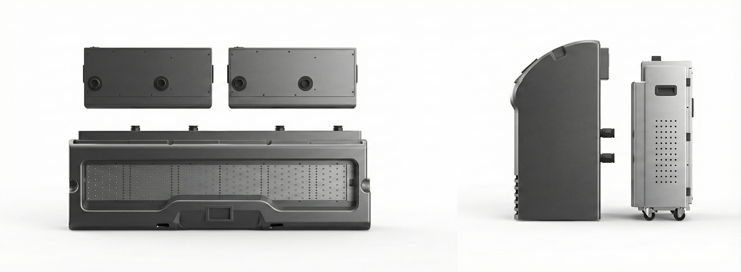
Figure 10: Tank and CDU Connection Illustration
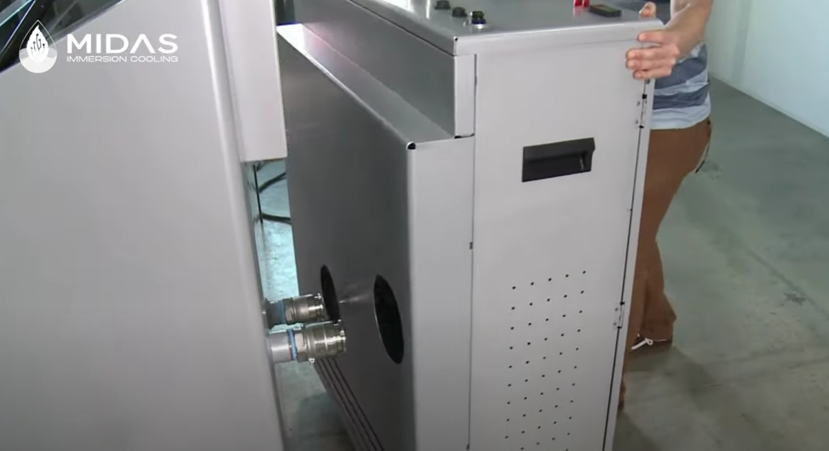
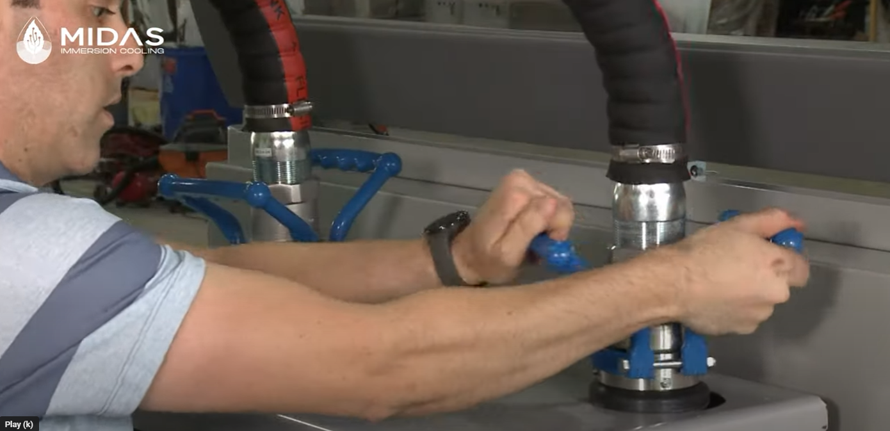
Figure 11: CDUs being actively replaced
Although some competitor options have redundant offerings, these do not have the hot-swappable capability of the Midas XCI system. This ensures the highest level of uptime in the industry and allows repairs to happen outside of the data center floor with minimal urgency.

Sensor Diagram
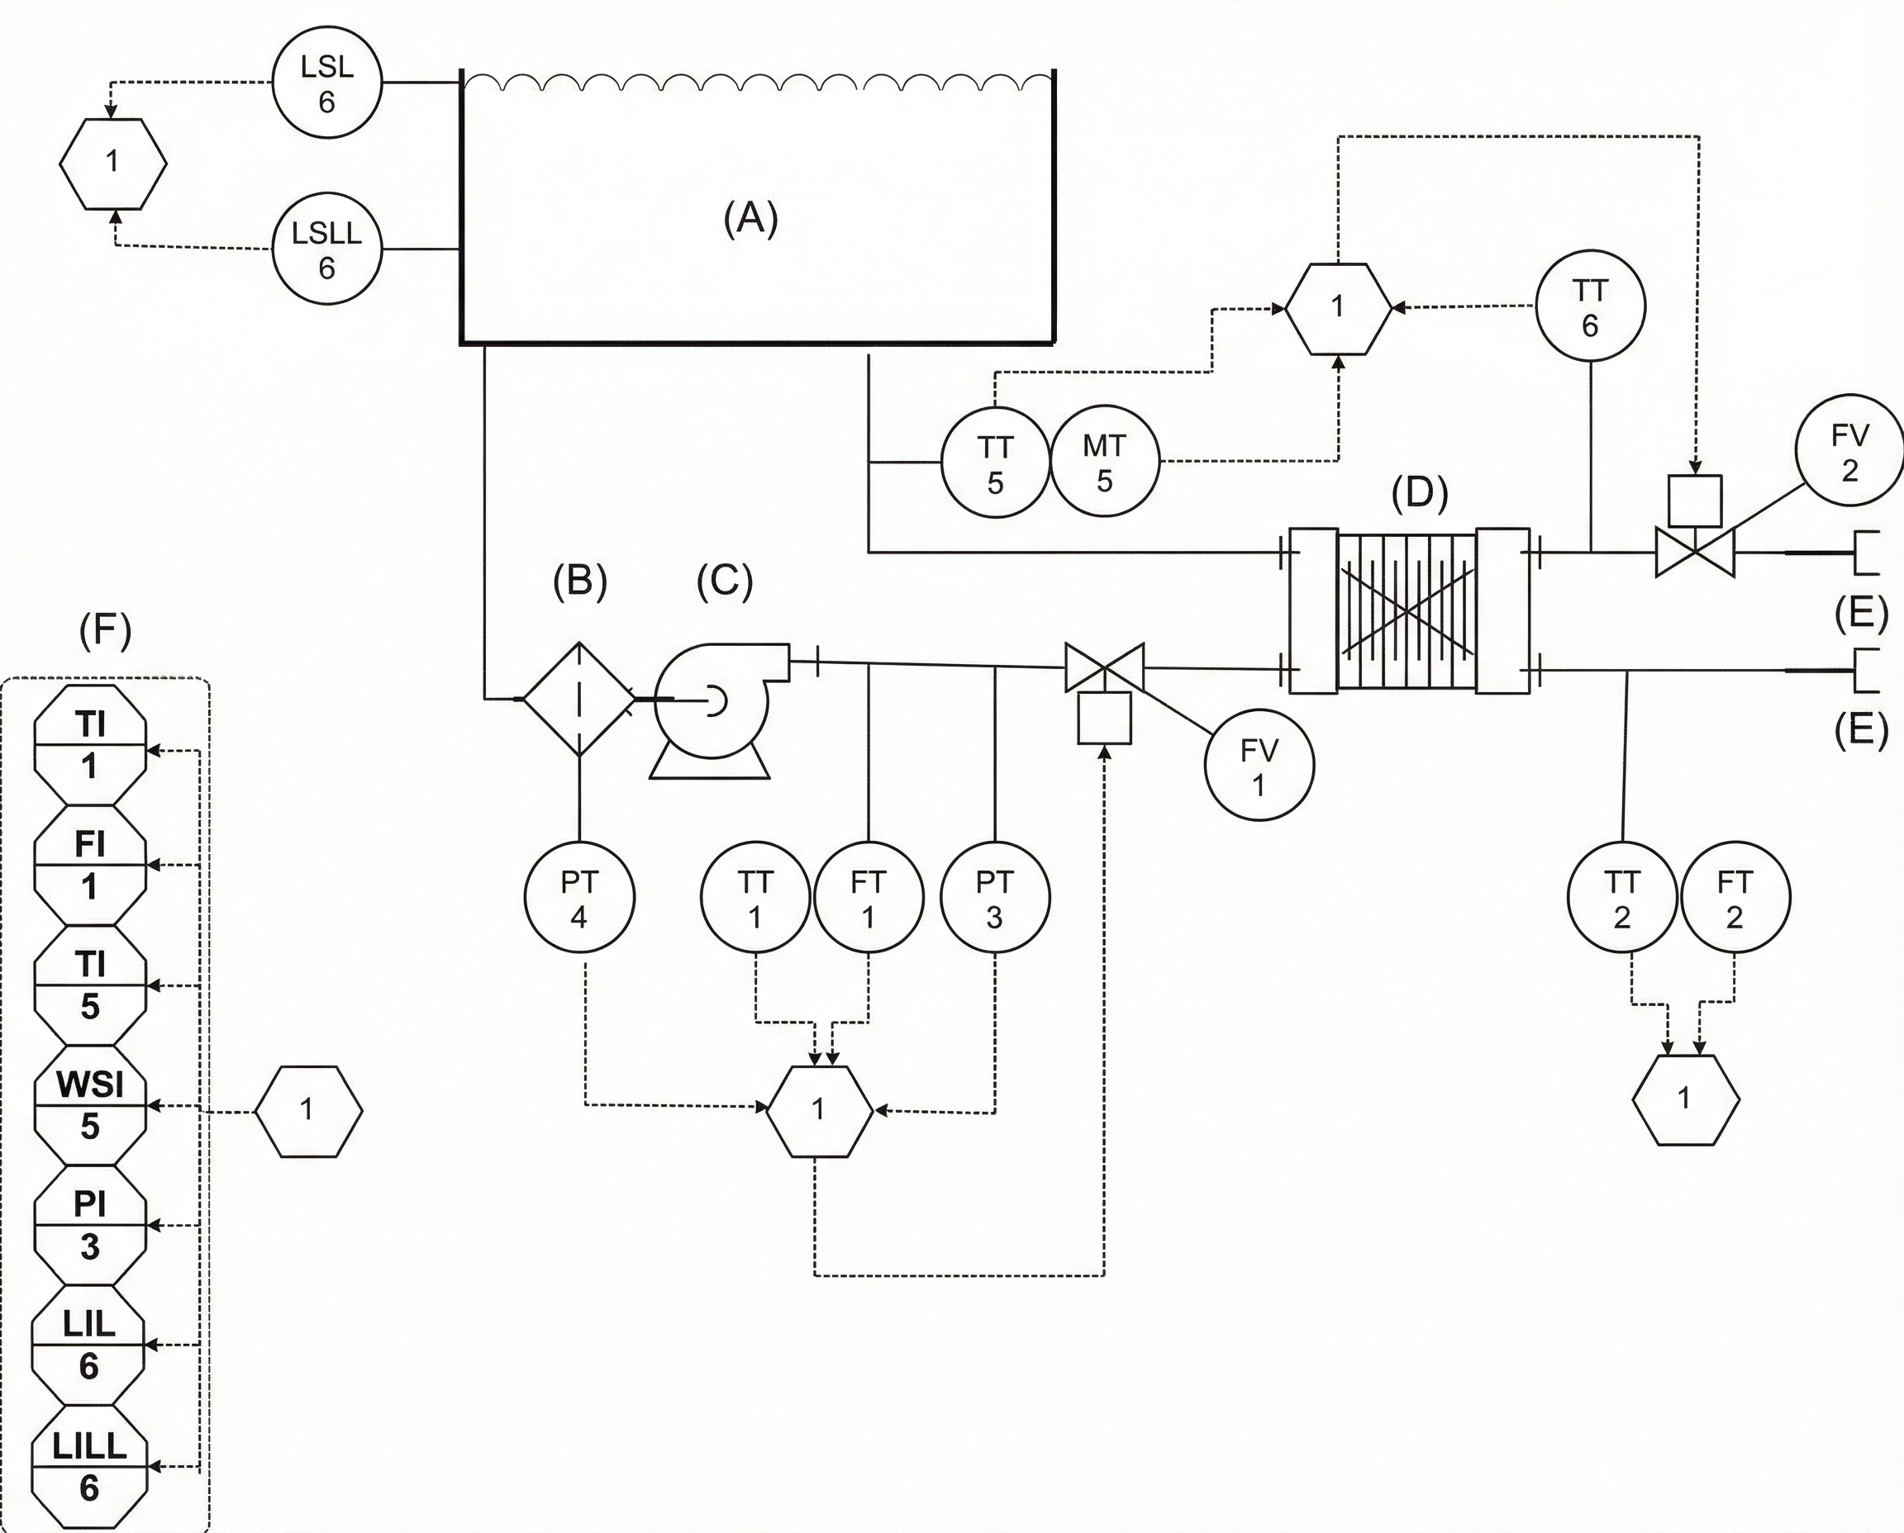
ITEM | DESCRIPTION | SYMBOL
A | TANK
B | STRAINER
C | PUMP
D | HEAT EXCHANGER
E | DRY DISCONNECT
F | SCREEN
1 | DIGITAL CONTROLLER
S1 | TEMPERATURE AND WATER SATURATION SENSOR | TT5, MT5
S2 | TEMPERATURE AND FLOWRATE SENSOR | TT1, FT1
S3 | PRESSURE SENSOR | PT3
S4,S5 | LEVEL SWITCH | LS,LLS
S6 | PRESSURE SENSOR | PT4
S7 | TEMPERATURE AND FLOWRATE SENSOR | TT2,FT2
S8 | TEMPERATURE SENSOR | TT6
V1 | VALVE (OIL SIDE) | FV1
V2 | VALVE (WATER SIDE) | VF2
Figure 12: Midas XCI 50U P&ID

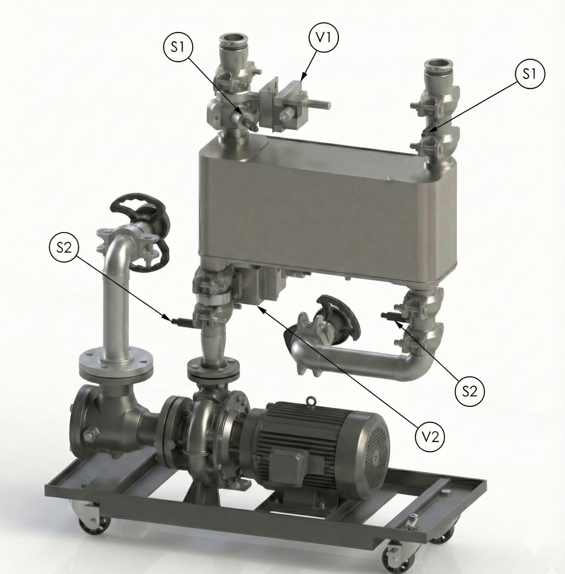
Figure 13: XCM6 without shell

Control
The Midas XCI system can be managed independently through a web interface or through SNMP.
The system can be configured for different operational modes and send alarms during specific failure scenarios.
Systems can be configured from the factory to customer specific setpoints and network configurations (Static IP or DHCP for example).
The following images show a few screenshots of the web interface and the point of contact display for the tank respectively.
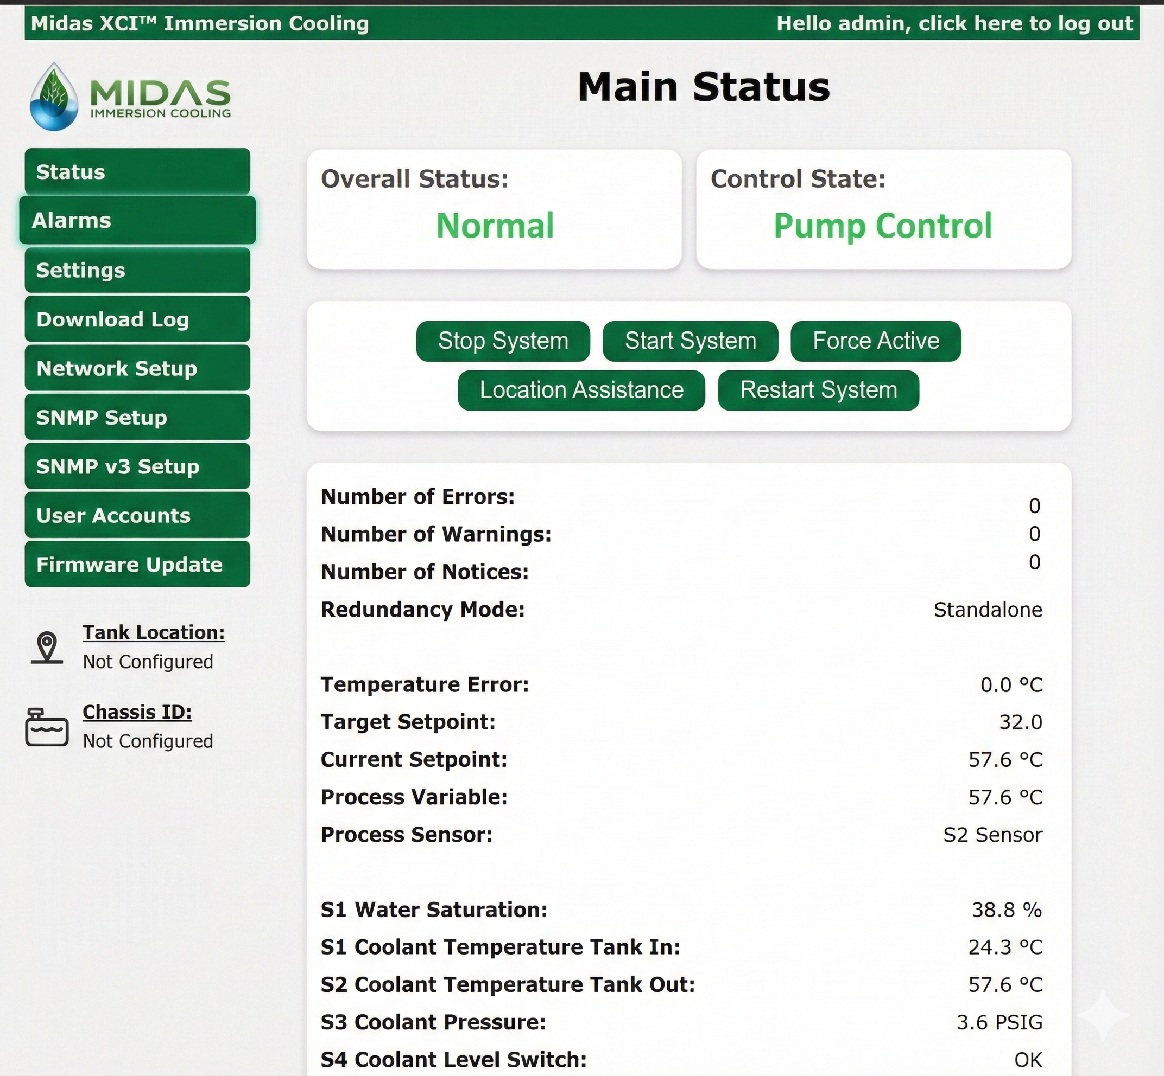Figure 14: Example of Web Interface- Main Status

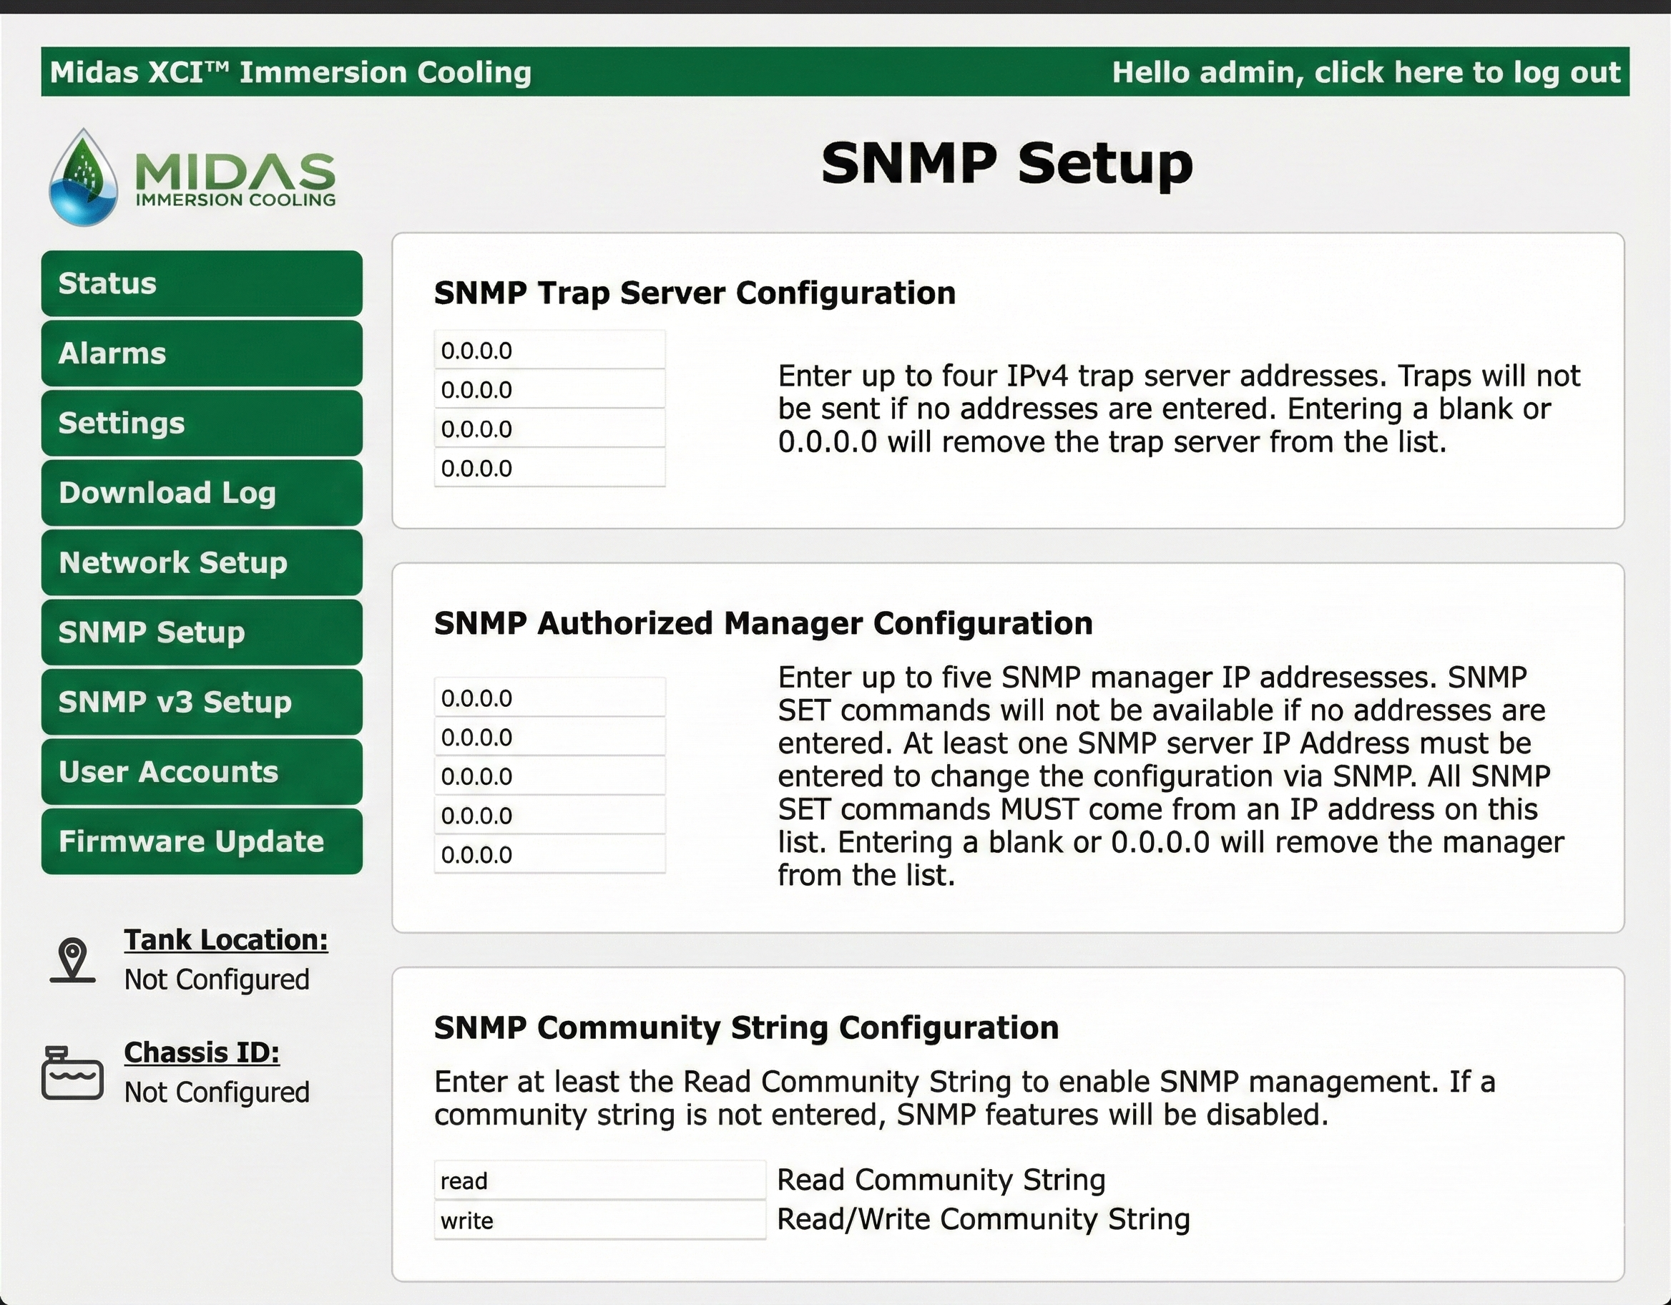
Figure 15: Example of Web Interface- SNMP Setup
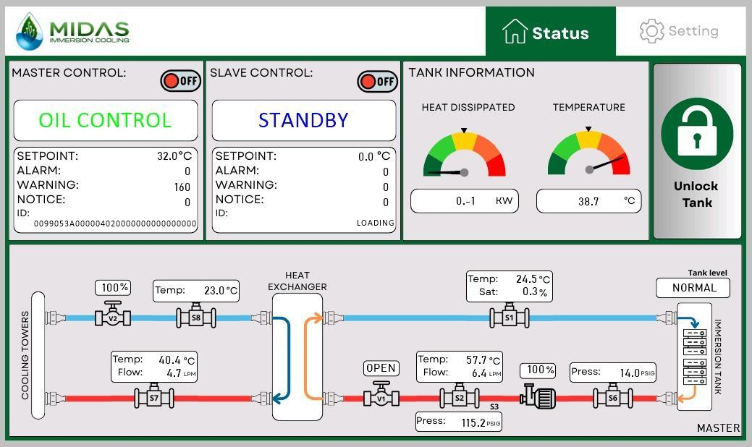
Figure 16: Tank Screen System Status

Preventive Maintenance Program
Midas systems are essentially service free. However, we offer a preventive maintenance program where a trained technician provides a thorough inspection of each tank and module. We provide maintenance to all moving parts, check electrical components and ensure there are no leaks.
If not buying an extended warranty or service agreement, we recommend performing this maintenance 11 months after deployment. This way we can check every component and replace anything that needs to be replaced under warranty.

Calculated Consumption and Performance
Calculated Consumptions are based on ASHRAE BIN data.
Calculations assume a constant load of 5MW. All load is distributed across 4 units. It is expected that during normal operation, all 5 units will share 20% of the load allowing to increase power and water efficiency.
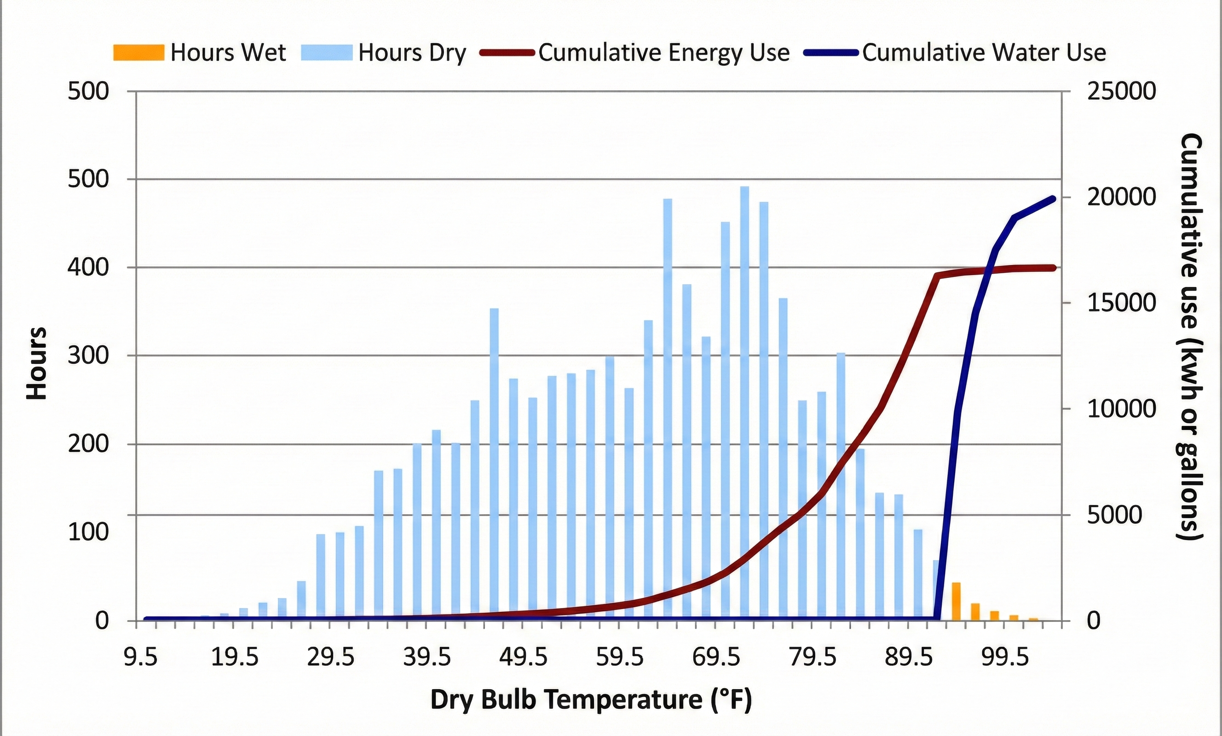
Figure 19: Adiabatic Cooler Expected Power and Water Consumption (per unit)
Table 4: Adiabatic Cooler yearly Water and Power Consumption (per unit)
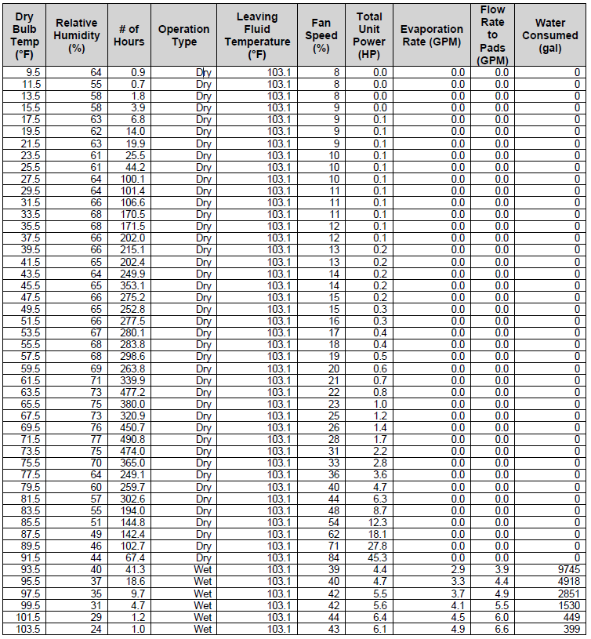

Preventive Maintenance Program
Midas offers an on-site preventive maintenance program for the adiabatic coolers where a trained technician from the manufacturer visits the site. The visit includes:
- Review entire unit to check for any refrigerant medium or water leaks
- Check pipe clamps to ensure they are tight with no pipe vibrations
- Review all the pads for damage, sediment and cleanliness, brush if necessary
- Review water treatment program with customer if needed
- Check cleanliness of coil
- Make sure no customer debris in the surrounding area
- Clean and flush water distribution headers and clean spray nozzles
- Check and clean the drain gutters
- Check fan motors, fan speeds and record amp draw
- Inspect electrical panel for any burned wires, contactors, electrical parts, fuses ok
- Shut off power and tighten electrical connections
- Record field power voltage at unit
- Check GMM set points, functions and alarm menu for trouble history
- Update Controller software if necessary
- Review GHM set points, functions, actuator and operation of water distribution over pads
- Check water inlet pressure for spray system
- Review with customer any operational issues or questions. Re-train as necessary
- Provide electronic manuals to customer
- Replacement parts not included in the maintenance inspection

Water Skid

General Description
The Water Skid is engineered to move the water between the coolers and the tanks. Please keep in mind that the drawings below are preliminary and can be adjusted based on site requirements. Also, please keep in mind that certain assumptions regarding pressure drop and fluid volume in the pipes were made. Skid might need to be adjusted once MEP finalizes piping design.

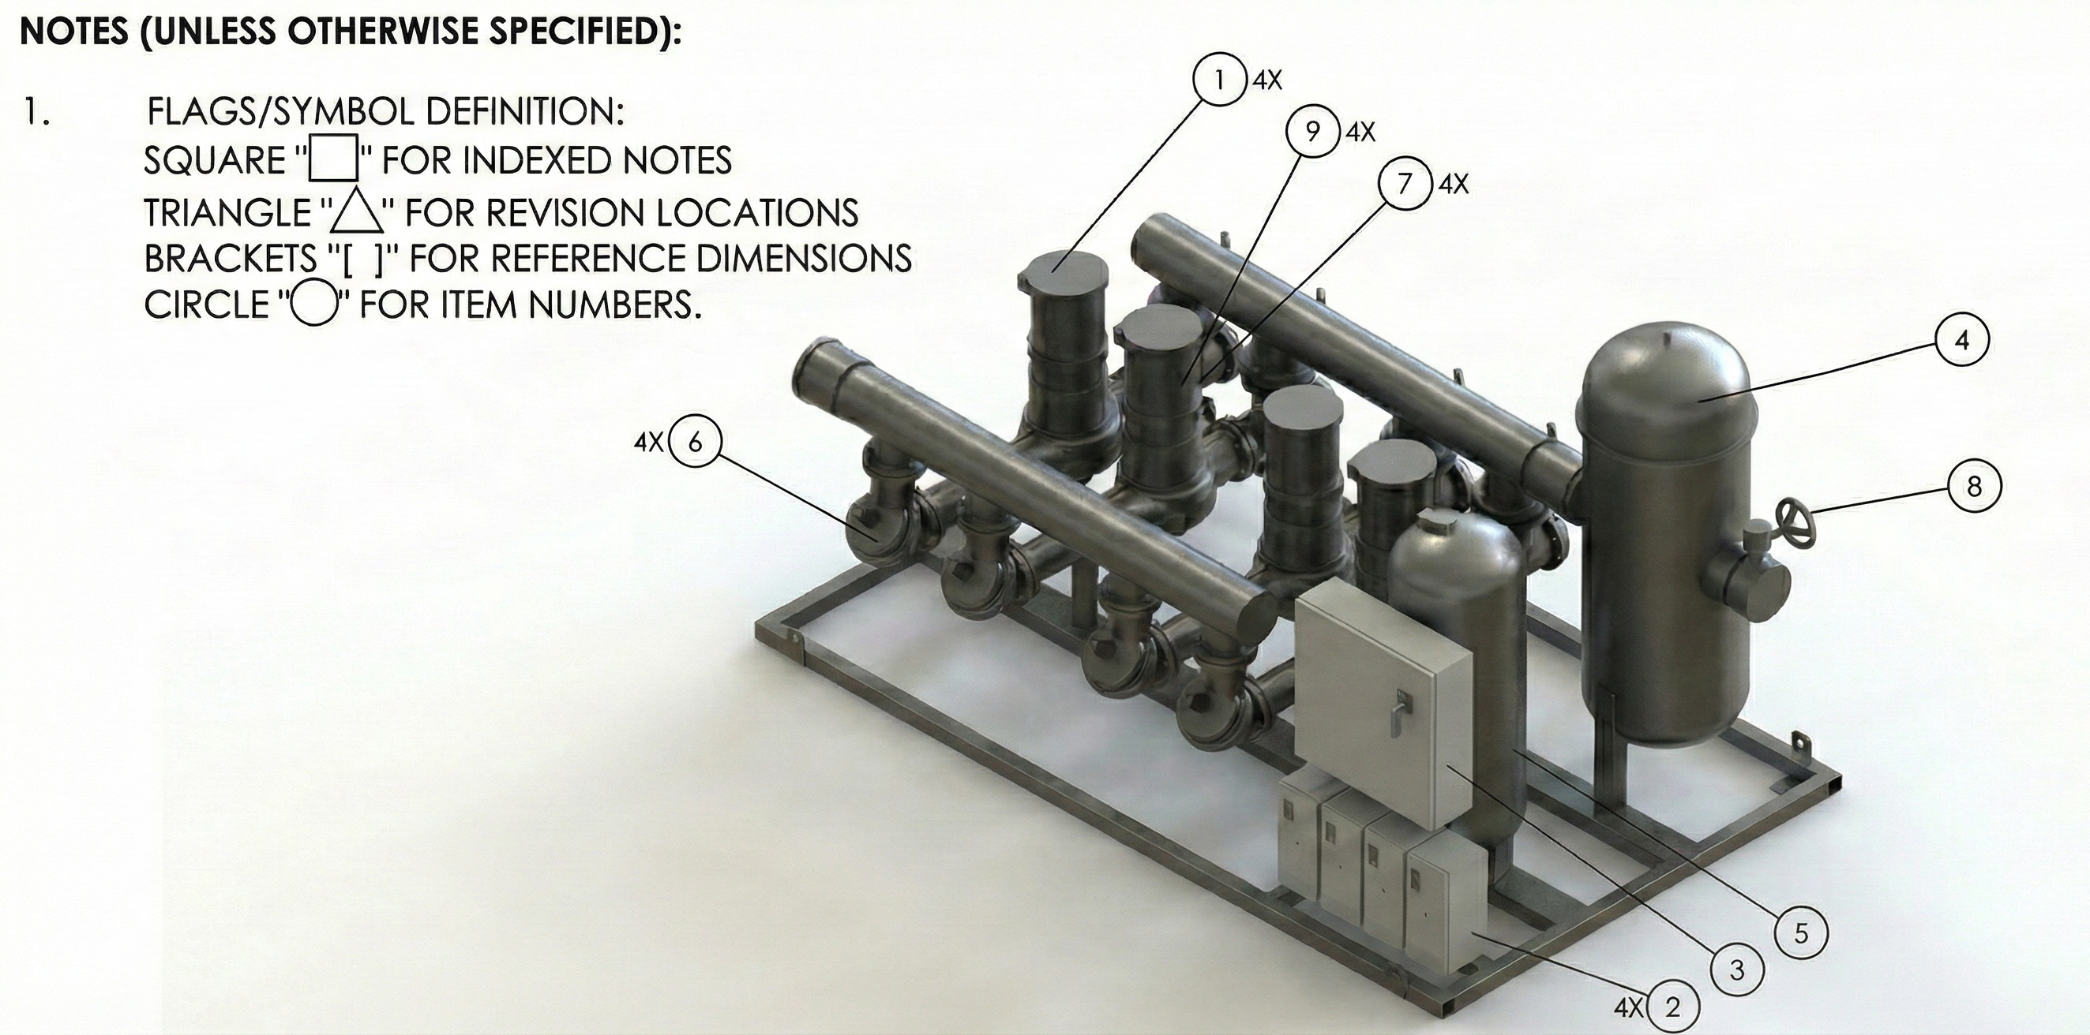
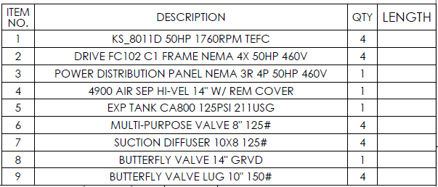
Figure 20 Water Skid Layout and BOM
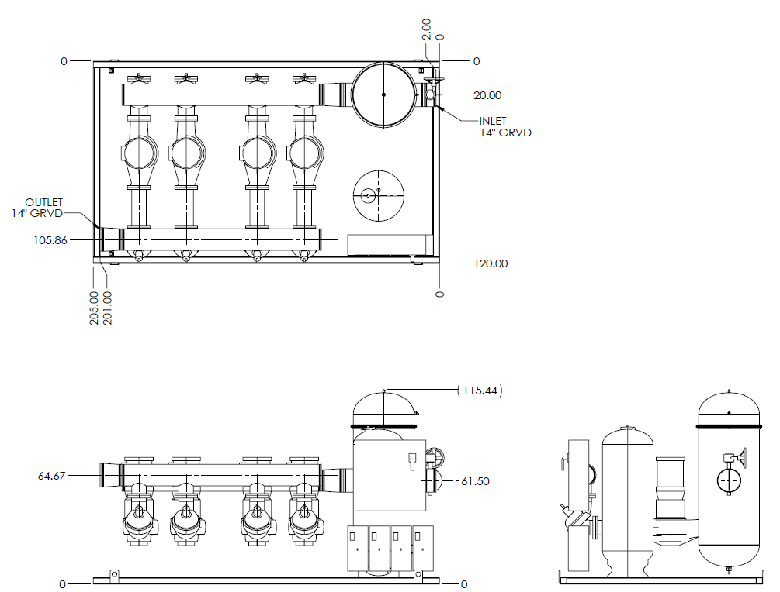
Figure 21: Water Skid Views and rough dimensions

Specifications
This selection is budgetary as we need the plumbing drawings from the MEP to calculate pressure drop across the system. 60-70’ TDH is normal across similar size deployments. The calculations were performed for 75’ TDH for power consumption calculations. From an infrastructure perspective, the pump configuration allows us to operate up to 90’ TDH as is. Higher pressure drops can be accomplished upgrading the motor.

Table 6: Water Skid Specifications
Duty Point | 4950 GPM @ 75' TDH
Redundancy | N+1
Total Number of Pumps | 4
Size of Largest Motor | 50hp
Voltage | 480V/3ph
VFD | Yes
Expected Power Consumption at full load | 85.8kW / 115HP
Outdoor Rated | Yes
Communications Package | Yes

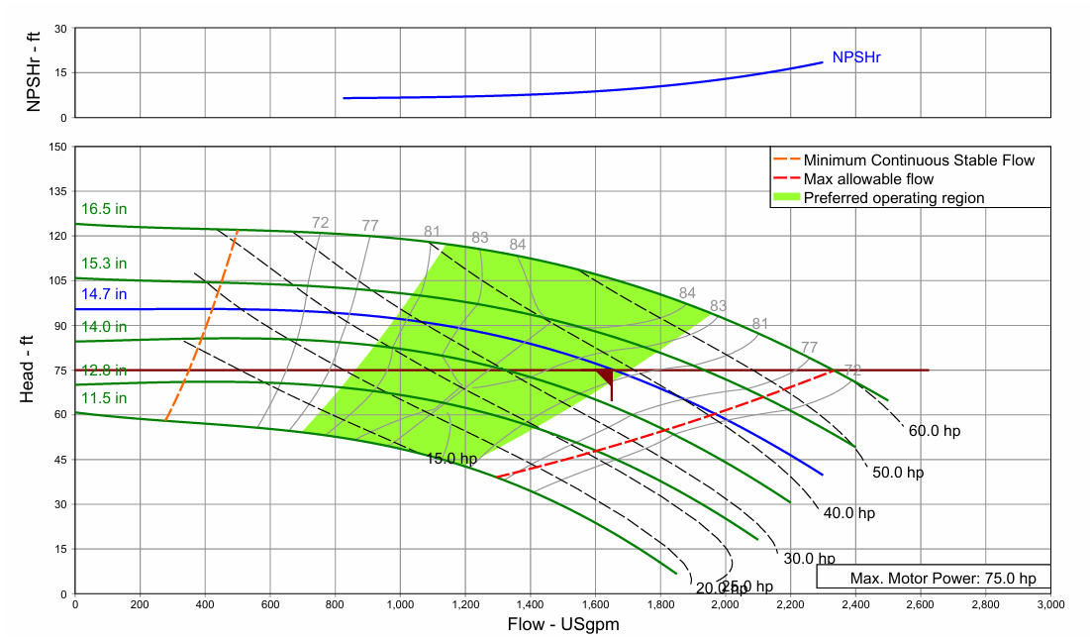
Figure 22: Pump Curve for Selected Pump at expected duty - 3 Pumps needed for flowrate
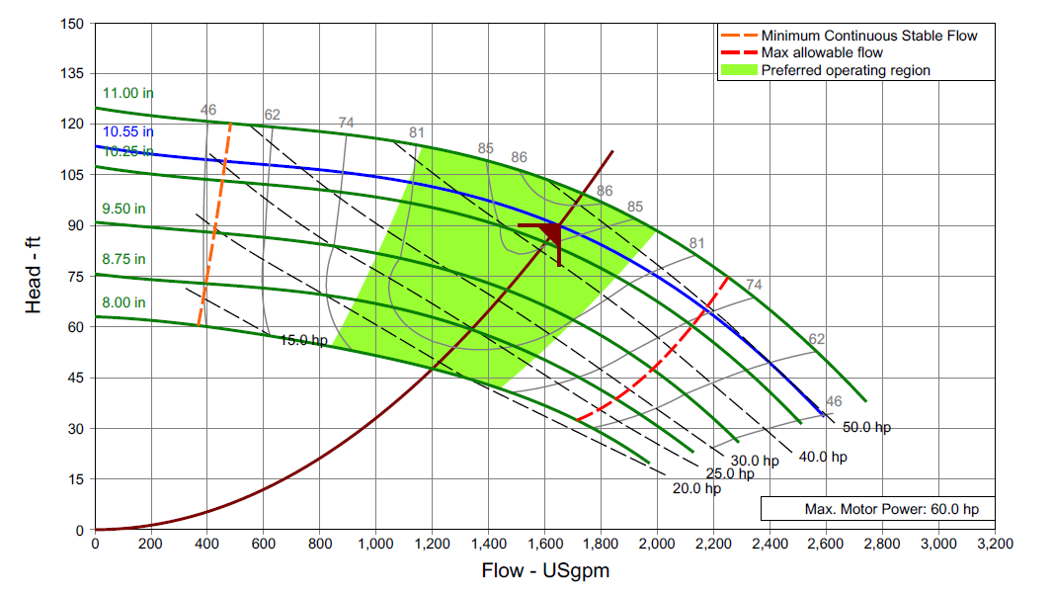
Figure 23: Pump Curve for Selected Pump at maximum duty - 3 pumps needed for flowrate.

Preventive Maintenance Program
Midas offers a preventive maintenance program where a trained technician provides a thorough inspection of the Water skid and performs the following maintenance tasks:
- Review entire unit to check for leaks
- Check pipe for vibrations
- Check Rotation
- Inspect Motors for damaged bearings
- Grease Motors
- Clean filter
- Check all valves
- Check motors speeds and amp draw
- Inspect electrical panel
- Shut off power and tighten electrical connections (optional)
- Record field power voltage at unit
- Check set points, functions and alarm menu for trouble history
- Update Controller software if necessary
- Review set points, functions, actuator and operation
- Review any operational issues or questions. Re-train as necessary

Technical Support Structure and Emergency Response Capabilities

Commissioning and Service
Midas has experience starting up and servicing over 420MW including 180 adiabatic coolers and pump skids and thousands of tanks in the field. Our site engineer is able to provide any help during the deployment period. After the systems have been deployed, we are able to troubleshoot most issues remotely or can travel if necessary.

Training
Midas offers Startup and Maintenance Services. Training is a standard part of our Startup and maintenance services. We will be happy to quote Training as a standalone service if requested.

Warranty and Service Agreements
All Midas provided items have a one-year warranty from deployment date. Refer to Appendix C for full terms and conditions of our standard warranty.
We also offer spare parts locker and/or an extended warranty for our products as well as service agreements with different levels of support ranging from parts only to full 4-hour response time.

Total Cost of Ownership Analysis

PUE Calculations
For our PUE we utilize two different approaches. The first, we calculate the maximum consumption of all the overhead equipment assuming everything is running at max speed. This gives us a ceiling of what the maximum overhead can be. The overhead power consumption cannot exceed this value even during the hottest hours of the year with all the workloads running at maximum.
For the second one, we use weather BIN data to calculate the system performance based on ambient conditions. This is the PUE that we expect to see on a yearly average.
Max Power (kW)
Server Power | Cooler Max (N) | Water Skid Max (N) | Tank Max | mPUE_max
5,000 | 287.19 | 86.80 | 61.54 | 1.087
Calculated Power (kW)
Server Power | Cooler expected | Water Skid Expected | Tank Expected | mPUE_exp
5,000 | 8.0 | 86.80 | 47.09 | 1.028

TCO Calculation
The total cost of ownership analysis is only inclusive of the scope of this proposal. Electrical infrastructure, real estate, personnel costs, etc. are not being considered. As it can be seen in the table and figures below, most of the OPX cost is spent on the power going to the IT. It is important to note that the decision to deploy immersion has already reduced this number by 10-20% due to the elimination of fans when compared with other technologies. Said in a different matter, 5MW of compute in immersion equate to roughly 10-25% more servers than if cooled using other technologies.

CAPX | Immersion Tanks |  | TBD
CAPX | Adiabatic Cooler |  | TBD
CAPX | Water Skid |  | TBD
CAPX | PDU |  | TBD
CAPX | Dielectric |  | TBD
CAPX | MEP |  | TBD
CAPX | Plumbing Infrastructure |  | TBD
CAPX | Electrical Infrastructure |  | TBD
CAPX | Control and DCIM Infrastructure |  | TBD
CAPX | Freight |  | TBD
CAPX | Equipment Deployment Costs |  | TBD
CAPX | TOTAL CAPX |  | TBD
OPX |  |  | Yearly Cost
OPX | Server Power Consumption (kW) | 5000.0 | TBD
OPX | Immersion Tanks Consumption (kW) | 47.1 | TBD
OPX | Adiabatic Consumption (kW) | 8.0 | TBD
OPX | Water Skid Consumption (kW) | 86.8 | TBD
OPX | Electrical Transmission Losses (kW) | 100.0 | TBD
OPX | Water Consumption (gal/year) | 80 | TBD
OPX | Extended Warranty (years 2-3) |  | TBD
OPX | Preventive Maintenance & Inspection |  | TBD
OPX | Out of Warranty Repairs/Maintenance (years 4-10) |  | TBD
OPX | TOTAL OPX |  | TBD

Figure 24: 10 Year TCO

Example: Project Timeline
The following example is based on a project kickoff date of 7/1. Delays on Kickoff times might cause non-linear shifts on the schedule.
Table 8: Project Schedule
Week | Date | Equipment | Startup Services | MEP + Plumbing
0 | 7/1 | Project Kickoff
1 | 7/8
2 | 7/15 |  |  | Preliminary Drawings for Plumbing Quotes
3 | 7/22
4 | 7/29 |  |  | Finalized Drawings
5 | 8/5
6 | 8/12 |  |  | Plumbing Vendor Selected
7 | 8/19
8 | 8/26
9 | 9/2
10 | 9/9
11 | 9/16
12 | 9/23
13 | 9/30
14 | 10/7
15 | 10/14 | Shipment of First Tank
16 | 10/21 |  | Deployment of First Tank | Plumbing materials arrive
17 | 10/28 |  |  | Plumbing Start
18 | 11/4 | Shipment of Water Skid
19 | 11/11
20 | 11/18 | Cooler Shipment
21 | 11/25 | Shipment of last tank | Deployment of Last Tank + Coolers + Water Skid | Plumbing Finished - Facility water loop fill-up and air purge
22 | 12/2 |  | Testing
23 | 12/9 |  | Commissioning Complete

General Contractor Services
Midas can offer general contractor services on services such as plumbing and electrical infrastructure. Due to the nature of these services, we need to hire an MEP to provide us with the relevant drawings and specifications. We can work under a flat fee or cost-plus model.
We would need to better understand the desired scope of our involvement for us to provide a quote.

APPENDIX A: Facility Drawing

APPENDIX B: Electrical Diagram

Appendix C: Sample Contract Terms

For sample MSA, please refer to the attached document:
“Midas Master Purchase and Sale Agreement.docx”

